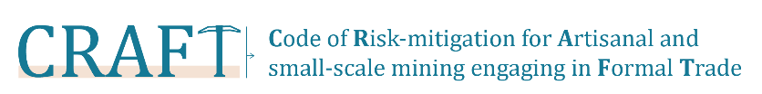

First public consultation round: February 26th to April 26th, 2018

Comments form

Welcome your comments, recommendations and questions to the following email address: standards@responsiblemines.org

For more information about the CRAFT Code please download the Code in the official consultation website.

Name:
Email address:
Name of the Organization that you represent:
Country:
Please tick here if you would like your comments to be kept anonymous? ☐
Please tick here if you would like to receive information about the development of the Code CRAFT? ☐

Module number | Comment | Proposed changed

